Unit 10: DNA, RNA, and Protein Synthesis Name:_____________________________per:____
Lesson 11.2; Read textbook pages 320-327

The Role of DNA (Read pg.320 and Figure 11-4 on pg. 321)
Role of DNA | Example of the Role (you may use the textbook for this)
Stores genetic information | Flowers may have genetic information for purple pigment
Copies the information | Every time a cell divides, it must make an exact copy of the purple pigment gene.
Gene (protein) Expression | Cells use the information to produce the purple pigment.

The Structure of DNA (Read pgs. 322-327)
- What type of (organic) macromolecule; (Protein, Lipid, Carbohydrate, Nucleic Acid) is DNA?
Nucleic Acid

- DNA is a long molecule (polymers) made up of (monomers) called
Nucleotides
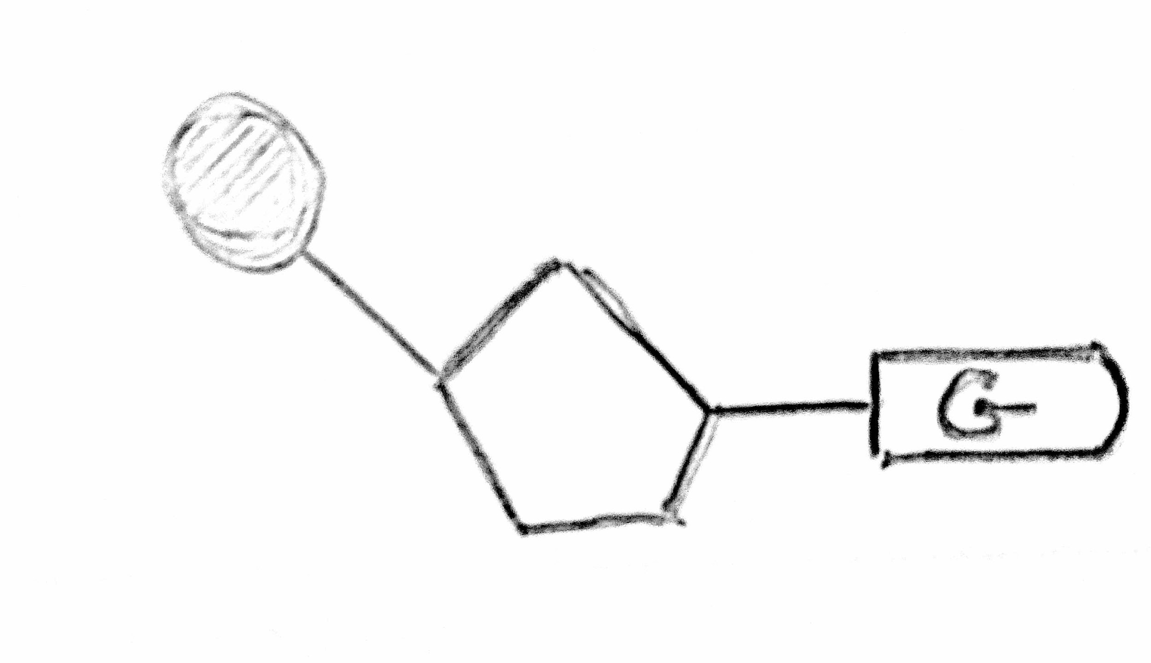
Phosphate
5-carbon Sugar
Nitrogen base
- Using figure 11-5; DRAW and INSERT a picture of a labeled nucleotide.
In the box.

- The 4 different nitrogen bases found within DNA are:
- Adenine
- Thymine
- Guamine
- Cytosine

- How are the 4 nitrogenous bases like the alphabet which contains 26 letters?
The 4 different nucleotides can be strung together in different order which leads to different information

- READ the Analyzing Data on the bottom of pg. 323 and answer the 3 questions below:
What pattern do you identify in the data?
Adenine & Thymine are close in amount as well as Guanine & Cytosine have similar amounts regardless of the organism.

If a species has 35% Adenine in its DNA, what is the percentage of the other 3 bases?
Thymine = 35%; Guanine = 15%; Cytosine = 15%

All DNA is composed of the 4 bases shown in the table. How is the pattern in the data useful for developing a model of DNA?
It allows us to see that A pairs with T. G pairs with C. DNA is double stranded and connected by nitrogen bases.

- Complete the assigned interactivity assigned in Google Classroom; DNA Structure
There is a question based off slide #5 in the interactivity

- In the DNA structure, the second strand is complementary to the first strand. What does the term ‘complementary’ mean in this context?
In this context it means ‘pairs with’ Each strand can be used to make the other strand.

- The DNA molecule is a double helix resembling a spiral staircase. DNA has_2_ sides (strands) and is; twisted or not-twisted. (circle one)

- DNA is antiparallel. What does this mean? And what does this allow for?
Antiparallel means….that the 2 strands of DNA run in opposite directions of each other

It allows...the nitrogen bases on both strands to come into close contact near the center of the molecule.
It allows...each strand of the double helix to carry a sequence of nucleotides (instructions for a protein)

- Why is it important that the 2 DNA strands were designed to be held by weak hydrogen bonds?
It will allow for the 2 strands of DNA to easily separate (DNA replication and transcription)

- Using the section of a model of DNA below; Label the following:
Deoxyribose Sugar, Phosphate; Nitrogen base, Hydrogen bond.

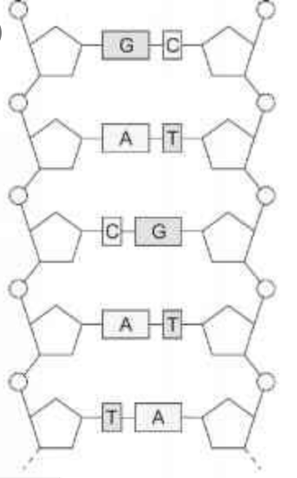
Deoxyribose sugar
Phosphate
Nitrogen base
Hydrogen bond

